**Electrodynamics HW Problems**

**07 – R&T, Dispersion, Conductors**

1. Wave equation in matter
2. Boundary conditions from Maxwell’s equations
3. R & T – perpendicular polarization
4. Anti-reflection lens coating
5. Driven damped harmonic oscillator
6. Spring constant of an atom
7. Dispersion in hydrogen gas
8. Skin depth for various conductors
9. Good/poor conductors
10. Birefringence of dextrose solution
11. Waves in plasmas
12. Power flow in a rectangular waveguide
13. TM modes in a rectangular waveguide
14. Cylindrical waveguide

**7.01. Wave equation in matter** [Dubson SP12]

Starting with Maxwell’s equation in matter (in terms of the **D** and **H** fields) show that, for a linear dielectric (**D**= ε**E**, **B**= μ**H**) with no free charges or currents (ρfree = 0, **J**free = 0), both the **E** and the **B** fields obey a wave equation with a wave speed given by .

**7.02. Boundary conditions from Maxwell’s equations** [Kinney SP11]

Maxwell’s equations in a matter with no free current or charge densities are:



Starting from these equations (or their integral versions), derive all the boundary conditions on **E** and **B** at a planar interface between two different linear materials (labeled 1 and 2), with permittivities and permeabilities ε1, μ1 and ε2, μ2, respectively. Assume there are no free charge or current densities.

**7.03. R & T – perpendicular polarization** [Pollock FA11, Kinney SP11]

Let the interface between two linear media be the *xy*-plane (*z* = 0), and the incident electric wave be



The propagation vector is .

Assume medium 1 has permittivity, permeability, and index of refraction ε1, μ1, and *n*1; those of medium 2 are ε2, μ2, and *n*2.

**(a)** Find the Fresnel equations for  and , and sketch  and

 for the case that μ1*n*2/μ2*n*1 = 1.5.

**(b)** Confirm that your Fresnel equations reduce to the correct forms at normal incidence.

**(c)** Compute the reflection and transmission coefficients *R* and *T*, and check that they add up to 1.

**(d)** For this polarization case and with distinguishable media (ε, μ, and *n* are different for the two media), is there a Brewster’s angle where the reflected amplitude is zero? If so, find an expression for the angle in terms of the media properties (*e.g.,* *n1*, *n2*).

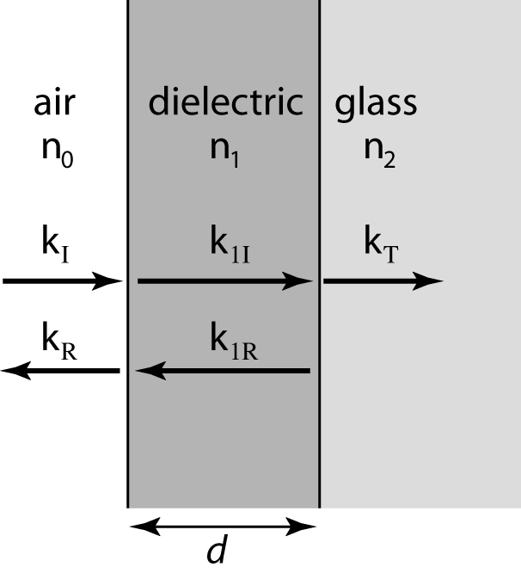**7.04. Anti-reflection lens coating**

[Pollock FA11, Kinney SP11, Munsat FA10, Rogers SP09]

A thin coating of dielectric material is deposited onto the surface of a glass lens, so that light entering the lens first goes through an air-dielectric interface before going through a dielectric-glass interface and then into the glass. The index of refraction of air is n0, (which you can set to 1), the dielectric is n1, and the glass is n2. You can assume that all μ’s equal μ0, and that the incoming light is polarized in the x direction.

**(a)** By matching the appropriate boundary conditions for all wave vectors shown in the drawing, show that the transmission coefficient for light of frequency *ω* entering the lens material is given by



where *d* is the thickness of the dielectric layer. [*Note: The algebra for this problem is not trivial. Work it out. Go slowly, be careful, use plenty of paper, don’t try to skip steps. Skill with this kind of algebra will be increasingly important to you! Also, see part (c) below, for another useful/relevant formula.*]

**(b)** You work for the Nikon lens company, and you are assigned the task of designing a dielectric coating that optimizes the transmission of glass lenses for light with *λ* ≈ 500 nm. Assume air has n0=1, glass has n2=1.5. What value of n1 would you choose, and how thick would you make the coating? (Explain your reasoning, briefly but clearly, in words as well as equations) What does T come out to be? Comment!

**(c)** In part (a), when finding T, you need to use the fact that .

Prove this expression is correct, where does it come from? (In particular, why is that factor of β out front, and why is it the absolute value squared, and NOT just (the Real part) squared?)

**7.05. Driven damped harmonic oscillator** [Dubson SP12]

Our microscopic model for the index of refraction involves a classical mass-spring system: a mass *m* attached to a fixed point with a spring of spring constant *k* = *m*ω02. The equilibrium length of the spring is zero. There is a friction force given by . The mass is driven by a (complex) external sinusoidal force .

**(cont…)**

**7.05. (cont.)**

**(a)** Write down the differential equation that describes the motion of this system.

**(b)** Assume a complex sinusoidal solution  and solve for ,  and δ. (Don’t skip any steps. You can find the answer in a textbook, so we are grading based on the quality of your derivation, not on the correctness of your final answer.)

**(c)** Assume , and use Mathematica to make a plot of the amplitude *x*0 vs. ω/ω0 and a plot of the phase shift δ vs. ω/ω0.

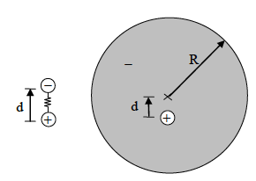**7.06. Spring constant of an atom** [Dubson SP12]

In class we have modeled an atom as an electron with mass *m* attached to the heavy nucleus with a spring. This atomic spring has zero equilibrium length and spring constant *k* = *m*ω0. Here we show that this model, though crude, is not crazy. Quantum mechanics tells us that in the ground state of hydrogen, the electron wave function is a spherically-symmetric cloud of charge centered on the atom. So, without too much violence to reality, we can model the electron as a uniform sphere of charge of radius *R* = Bohr radius = 0.53 angstroms). When an external E-field is applied, the nucleus is pushed one way and the electron cloud is pushed the other way, so there is an induced dipole moment. We assume that the electron’s sphere of negative charge is not distorted in shape when it is displaced. We also assume that the nucleus is so heavy that it remains stationary, while the electron cloud can oscillate about the stationary nucleus.

**(a)** Show that when the nucleus is displaced from the center of the electron cloud by a distance *d* < *R*), there is a restoring force that is proportional to *d*. Derive an expression the spring constant k in this situation.

**(b)** Compute the value of the spring constant k, for the case of a hydrogen atom. Give the answer in both SI units (N/m = J/m2) and in slightly more natural units of electron-volts per angstrom2 (eV/Å2). What is the natural frequency f0 = ω0/2π (in Hz) for this mass-spring system?

**(c)** What is the wavelength of light that has this frequency? (Give your answer in nanometers.) What part of the spectrum does this correspond to? (Visible?, IR?, UV?, radio?, etc…)

**7.07. Dispersion in hydrogen gas** [Pollock FA11, Kinney SP11]

When we first studied polarization in matter, we used a very simple atomic model to estimate the atomic polarizability from a static electric field. Now let’s apply it for non-static fields.

**(a)** Assume the hydrogen atom is a point nucleus of charge *+e* and mass *mp* surrounded by a sphere of uniform charge density of radius *r*H and total charge *–e*. In the absence of any external field, the equilibrium position of the nucleus is at the center of sphere. Find the force on the nucleus if it is displaced from the center by a distance *d* and use this to find an “effective” spring constant *k*. What is the natural frequency of oscillation for the hydrogen atom in this model? Putting in the actual values for the variables (the radius will be approximate of course), where in the electromagnetic spectrum does this frequency lie?

**(b)** For EM waves with frequencies far from the region of anomalous dispersion, we can ignore damping and use:



or  in terms of the wavelength, to predict the coefficients of refraction and dispersion for hydrogen. Use numbers from part (a), and calculate these coefficients for hydrogen gas at 0°C and 1 atm pressure, and compare them with the measured values of  and .

**7.08. Skin depth for various conductors** [Kinney SP11, Munsat FA10]

**(a)** Show that the skin depth for a “good conductor” (*i.e.,* ) is , where  is the wavelength in the conductor. Find the skin depth for microwaves in copper ( GHz).

**(b)** Show that the skin depth for a “poor conductor” (*i.e.,* ) is  (notice that it does not depend on frequency or wavelength). Find the skin depth for microwaves in pure water.

**7.09. Good/poor conductors** [Dubson SP12, Pollock FA11]

In class we derived equations for EM waves in conductors, assuming a “good conductor” (where σ >> εω). Interestingly, it turns out that the formulas we got can be pushed a good deal further than you might naively expect, into regimes where e.g., σ is not so large (“poor conductors”). In this case, you will need to use the more careful results for the real and imaginary parts of the k vector:

 

**(a)** Based on the above comments, show that the skin depth for a “poor conductor” (*i.e.,* σ << εω) is , independent of frequency or wavelength. Work out what the “??” is in this equation.

Then, show (using the equations above) that the skin depth for a “good conductor” (σ >> εω) is , where λ is the wavelength in the conductor.

**(b)** For biological tissues (like skin), ε and σ depend on frequency, and you can’t use their free space values. (μ on the other hand is close to its free space value) At microwave frequencies (say, about 2.5 GHz), their values are ε = 47ε0 and . Is this the “good conductor” or “poor conductor” case, or neither?

Evaluate the skin depth for microwaves hitting your body. If such an EM wave (e.g., from a radar station) hits your body at this frequency, roughly what fraction of the incident power do you absorb?

***Hint****: Compute the reflection coefficient* *, then argue that whatever is not reflected must be absorbed.*

**(c)** It is difficult to communicate by radio with submarines because it is not easy to make radio waves that can penetrate seawater. For radio waves with frequency of say, 3 kHz, evaluate the skin depth in the sea, and comment on the feasibility/issues of such radio communication. (What is the wavelength of this same radio wave in *free space*, by the way?)

***Hint****: You can use given values from part (b) where needed, although as mentioned above, in reality they’ll be different at this different frequency.)*

**7.10. Birefringence of dextrose solution** [Kinney SP11, Munsat FA10]

**(a)** A dextrose solution responds to electric fields with a polarization given by , where  is a constant that depends on the dextrose concentration. The solution is non-conducting () and non-magnetic (). Suppose that we arrange for a plane wave to propagate through the dextrose solution in the  direction, *i.e.,* . Assume this and then, starting from Maxwell’s equations, show that the electric field satisfies the equation



**(b)** Show that for positive wave numbers *k* and assuming that , there are two indices of refraction () possible for plane waves in the dextrose solution, which are given by:

 .

This explains why dextrose admits propagation of two different wave modes through two different indices of refraction. The Handbook of Physics and Chemistry says that for an aqueous dextrose concentration of 0.01 gram per cc, one wave lags behind the other by about 6.7° per cm of propagation.

**7.11. Waves in plasmas** [Munsat FA10]

**(a)** Consider a neutral plasma (gas of electrons and positive ions), with electron density . At high frequencies, because the ions are very heavy, we can consider them to be essentially fixed and any current due solely to the light electrons. The total charge density can be set to zero for an electrically neutral gas. Use Maxwell's Equations to derive the wave equation for the electric field:



**(b)** For a monochromatic wave, , and ignoring any collision between electrons (mass ), use Newton's law to relate E and J and show that

 where  is the plasma frequency.

**(c)** Derive the dispersion relation . Sketch the graph of .

**(d)** Give the real electric field when .

**7.12. Power flow in a rectangular waveguide** [Kinney SP11, Munsat FA10]

Consider the TE10 mode in a rectangular waveguide oriented for transporting waves in the -direction, with side lengths *a* in the *x*-direction and *b* in the *y*-direction. Assume *a* > *b*.

**(a)** Find the time-averaged energy density  (as a function of *x* and *y*) and the time-averaged Poynting vector  (as a function of *x* and *y*) inside the waveguide.

**(b)** Now spatially average these quantities over the cross-sectional area of the waveguide to find  and .

**(c)** We previously used the equation  to “define” the speed  of energy flow; use it here to find the speed of energy flow in the waveguide. Does this speed make sense?

**7.13. TM modes in a rectangular waveguide** [Kinney SP11]

In the text, the theory of TE modes is derived for a rectangular waveguide. Now it’s your turn to derive the theory of TM modes for a rectangular waveguide of side-lengths *a* and *b* oriented to propagate waves along the *z*-direction.

**(a)** Find the general solution for the longitudinal (*E*z) electric field, and using the boundary conditions find the allowed modes for TM waves.

**(b)** Find the cutoff frequency, the wave (phase) velocity, and the group velocity for the TMmn mode.

**(c)** What is the lowest TM mode? Find the all the components of the electric and magnetic fields for this mode as a function of *x*, *y*, *z*, and *t*. Make a sketch showing the magnetic field as a function of *x* and *y* at such a *z* and *t* that .

**7.14. Cylindrical waveguide** [Munsat FA10]

Consider a cylindrical waveguide with radius *a*, oriented in the -direction.

**(a)** Construct a pair of differential equations for  and  by transforming



into cylindrical coordinates.

**(b)** Solve the equation by separation of variables to show that the TE mode solutions for cylindrical waveguides are given by



where  is a constant and m is an integer.

**(c)** Find the condition that determines  for a given TEm waveguide mode corresponding to the integer m.

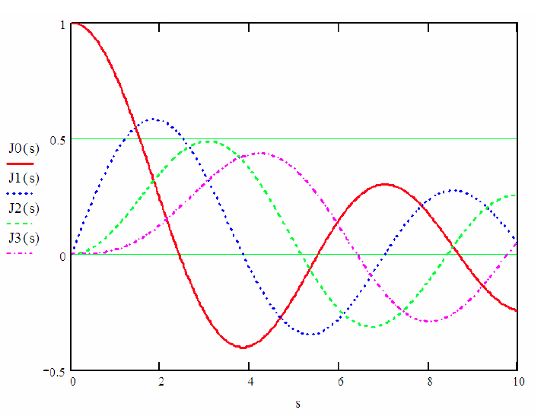

For this problem you will need to be familiar with Bessel functions , which satisfy Bessel’s equation:



The first few Bessel functions are plotted at right.